James Jennings Week 2 Notes

This week, I’ll be starting my Web120 portal website.

I’ve completed the following assignments already:

* Monday, i watched the live webinar (i was working all weekend; not easy to be a full time student and work full time!)
* Tuesday, i answered questions regarding the webinar and started my class notes
* Friday i worked in the computer lab at school to publish my Portal site and to make the necessary changes to fulfill the homework requirements.

Desktop view of Portal site:

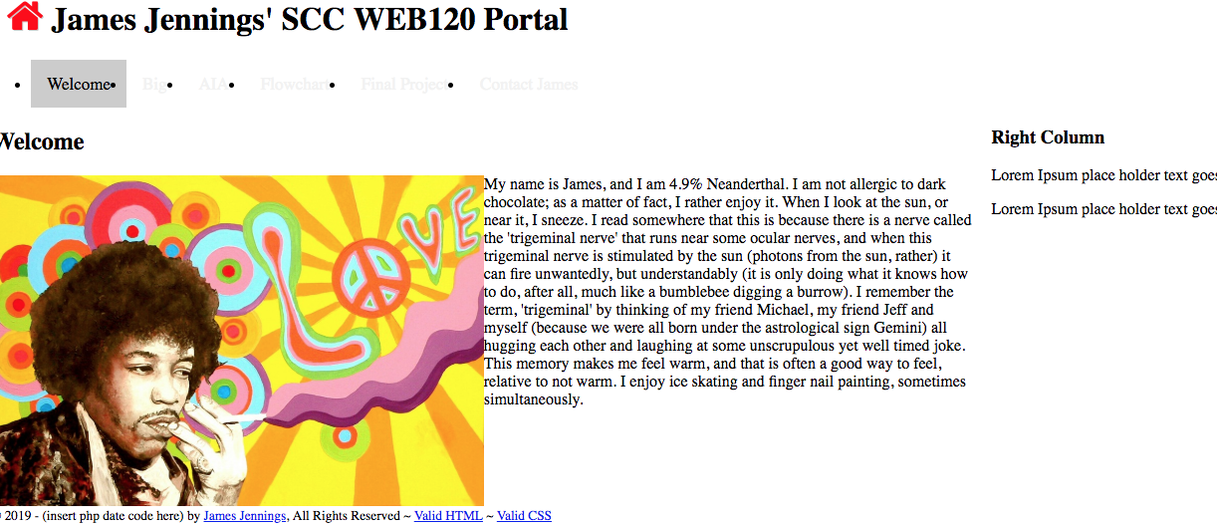

Mobile view of Portal Site:

